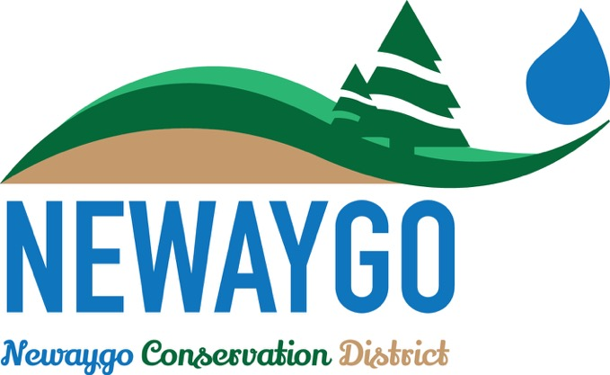
Newaygo Conservation District Sponsorship Form

Sponsor Information (please print or type)

Name

Billing address

City, State, Zip Code

Phone 1 | Phone 2

Fax | Email

Pledge Information
I (we) pledge a total of: ☐$10 ☐$20 ☐$50 ☐$100 ☐other__________________
Donations must be made in the form of cash or check.

Additional Information
Please use the following space to include a small description of the services you provide or a business motto you’d like to include:

Logo Use
Please email your business logo to newaygocd@macd.org so we can acknowledge your contribution to our event. Your logo will be used on any advertisement for the event, unless we are given permission to use it elsewhere.
☐I (we) wish to have our gift remain anonymous.
Signature(s) |  | Date
Please make checks, corporate matches,  or other gifts payable to: |  | Newaygo Conservation District  940 Rex Street  Fremont, MI 49412

